Working with Favorites
The favorites menu allows quick access to pages accessed frequently without having to manually navigate to them. You can add to the Favorites menu from anywhere in the application.

Adding to Favorites:
- Navigate to the page you would like to add to your Favorites menu.
- Click on the Actions List icon in the top right corner of the page.
- Select Add to Favorites from the Actions List menu. This adds the current page to your Favorites menu. 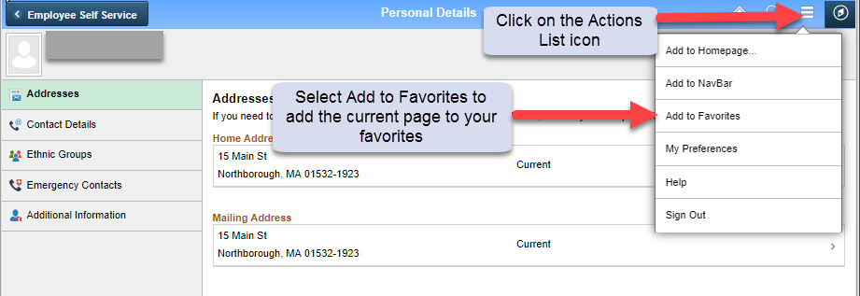

Navigating to your Favorites:
To access your Favorites, click on the NavBar icon in the upper right corner from any page.

From a Desktop:
- Open the NavBar by clicking the compass symbol in the upper right corner of the page.
- Select the My Favorites icon from the NavBar. This opens a list of all of your favorites.
- Select the Favorite to navigate to the corresponding page.

From a Mobile Device:
- Tap the Actions List icon and select NavBar.
- Tap on the My Favorites icon from the NavBar. This opens a list of all of your favorites.
- Tap the Favorite to navigate to the corresponding page.

Editing/Deleting Favorites (desktop only):
- To access your Favorites, click on the NavBar icon in the upper right corner from any page.
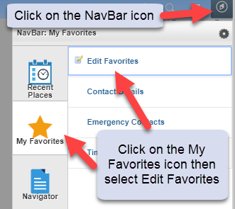
- Select Edit Favorites from the menu list. This will display the Edit Favorites page where you can edit and/or delete any favorites you have added to your list.
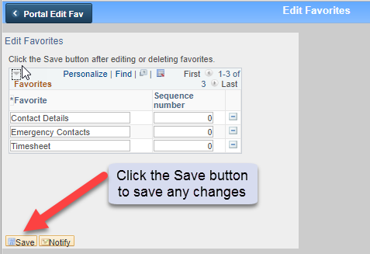
- Select the Save button to save the changes to your Favorites.

